**Bài tập lí thuyết Chương 5**

*Bài 1: Thực hiện đếm bậc các đỉnh tại ví dụ 5.1, 5.2, 5.3, 5.6*

Bậc của đỉnh là số cạnh liên thuộc với đỉnh.

VD 5.1:

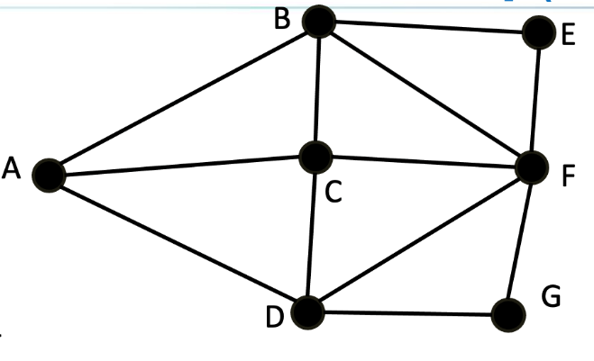

deg(A) = 3

deg(B) = 4

deg(C) = 4

deg(D) = 4

deg(E) = 2

deg(F) = 5

deg(G) = 2

VD 5.2:

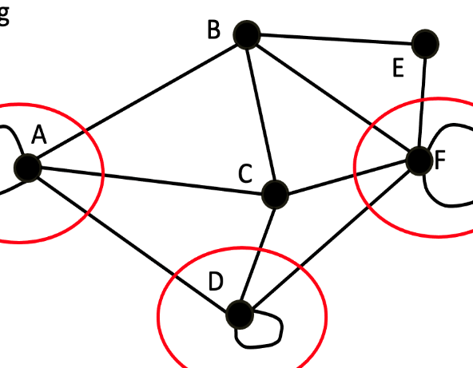deg(A) = 3

deg(B) = 4

deg(C) = 4

deg(D) = 3

deg(E) = 2

deg(F) = 4

VD 5.3:

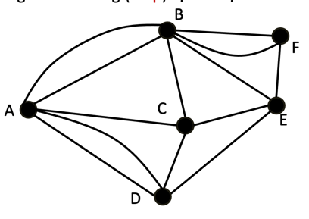

deg(A) = 5

deg(B) = 6

deg(C) = 4

deg(D) = 4

deg(E) = 4

deg(F) = 3

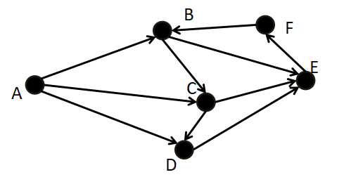VD 5.6:

deg+(A) = 3

deg-(A) = 0

deg+(B) = 2

deg-(B) = 2

deg+(C) = 2

deg-(C) = 2

deg+(D) = 1

deg-(D) = 2

deg+(E) = 1

deg-(E) = 3

deg+(F) = 1

deg-(F) = 1

*Bài 2: Cho biết ma trận kề của đồ thị tại ví dụ 5.1, 5.6, 5.7, 5.11*

VD 5.1:

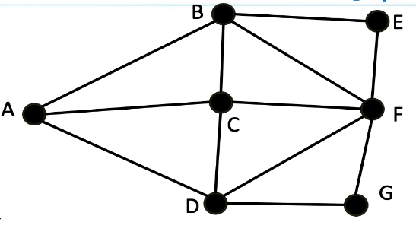

|  |  |  |  |  |  |  |  |
| --- | --- | --- | --- | --- | --- | --- | --- |
|  | A | B | C | D | E | F | G |
| A | 0 | 1 | 1 | 1 | 0 | 0 | 0 |
| B | 1 | 0 | 1 | 0 | 1 | 1 | 0 |
| C | 1 | 1 | 0 | 1 | 0 | 1 | 0 |
| D | 1 | 0 | 1 | 0 | 0 | 1 | 1 |
| E | 0 | 1 | 0 | 0 | 0 | 1 | 0 |
| F | 0 | 1 | 1 | 1 | 1 | 0 | 1 |
| G | 0 | 0 | 0 | 1 | 0 | 1 | 0 |

VD 5.6:



|  |  |  |  |  |  |  |
| --- | --- | --- | --- | --- | --- | --- |
|  | A | B | C | D | E | F |
| A | 0 | 1 | 1 | 1 | 0 | 0 |
| B | 0 | 0 | 1 | 0 | 1 | 0 |
| C | 0 | 0 | 0 | 1 | 1 | 0 |
| D | 0 | 0 | 0 | 0 | 1 | 0 |
| E | 0 | 0 | 0 | 0 | 0 | 1 |
| F | 0 | 1 | 0 | 0 | 0 | 0 |

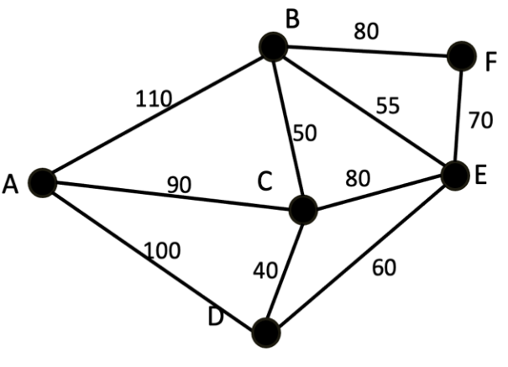VD 5.7:

|  |  |  |  |  |  |  |
| --- | --- | --- | --- | --- | --- | --- |
|  | A | B | C | D | E | F |
| A | 0 | 110 | 90 | 100 | 0 | 0 |
| B | 110 | 0 | 50 | 0 | 55 | 80 |
| C | 90 | 50 | 0 | 40 | 80 | 0 |
| D | 100 | 0 | 40 | 0 | 60 | 0 |
| E | 0 | 55 | 80 | 60 | 0 | 70 |
| F | 0 | 80 | 0 | 0 | 70 | 0 |

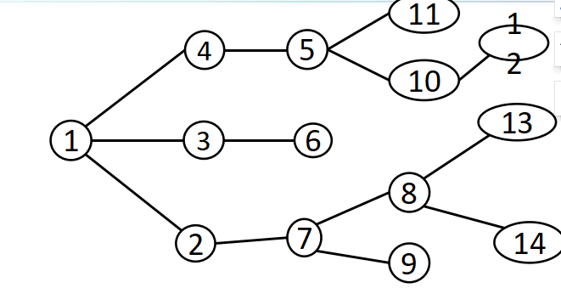VD 5.11:

|  |  |  |  |  |  |  |  |  |  |  |  |  |  |  |
| --- | --- | --- | --- | --- | --- | --- | --- | --- | --- | --- | --- | --- | --- | --- |
|  | 1 | 2 | 3 | 4 | 5 | 6 | 7 | 8 | 9 | 10 | 11 | 12 | 13 | 14 |
| 1 | 0 | 1 | 1 | 1 | 0 | 0 | 0 | 0 | 0 | 0 | 0 | 0 | 0 | 0 |
| 2 | 1 | 0 | 0 | 0 | 0 | 0 | 1 | 0 | 0 | 0 | 0 | 0 | 0 | 0 |
| 3 | 1 | 0 | 0 | 0 | 0 | 1 | 0 | 0 | 0 | 0 | 0 | 0 | 0 | 0 |
| 4 | 1 | 0 | 0 | 0 | 1 | 0 | 0 | 0 | 0 | 0 | 0 | 0 | 0 | 0 |
| 5 | 0 | 0 | 0 | 1 | 0 | 0 | 0 | 0 | 0 | 1 | 1 | 0 | 0 | 0 |
| 6 | 0 | 0 | 1 | 0 | 0 | 0 | 0 | 0 | 0 | 0 | 0 | 0 | 0 | 0 |
| 7 | 0 | 1 | 0 | 0 | 0 | 0 | 0 | 1 | 1 | 0 | 0 | 0 | 0 | 0 |
| 8 | 0 | 0 | 0 | 0 | 0 | 0 | 1 | 0 | 0 | 0 | 0 | 0 | 1 | 1 |
| 9 | 0 | 0 | 0 | 0 | 0 | 0 | 1 | 0 | 0 | 0 | 0 | 0 | 0 | 0 |
| 10 | 0 | 0 | 0 | 0 | 1 | 0 | 0 | 0 | 0 | 0 | 0 | 1 | 0 | 0 |
| 11 | 0 | 0 | 0 | 0 | 1 | 0 | 0 | 0 | 0 | 0 | 0 | 0 | 0 | 0 |
| 12 | 0 | 0 | 0 | 0 | 0 | 0 | 0 | 0 | 0 | 1 | 0 | 0 | 0 | 0 |
| 13 | 0 | 0 | 0 | 0 | 0 | 0 | 0 | 1 | 0 | 0 | 0 | 0 | 0 | 0 |
| 14 | 0 | 0 | 0 | 0 | 0 | 0 | 0 | 1 | 0 | 0 | 0 | 0 | 0 | 0 |

*Bài 3: Cho biết danh sách kề của đồ thị tại ví dụ 5.1, 5.7, 5.8, 5.11*

Vd 5.1:

|  |  |
| --- | --- |
| Đỉnh | Danh sách kề |
| A | {B, C, D} |
| B | {A, C, E, F} |
| C | {A, B, D, F} |
| D | {A, C, F, G} |
| E | {B, F} |
| F | {B, C, D, E, G} |
| G | {D, F} |

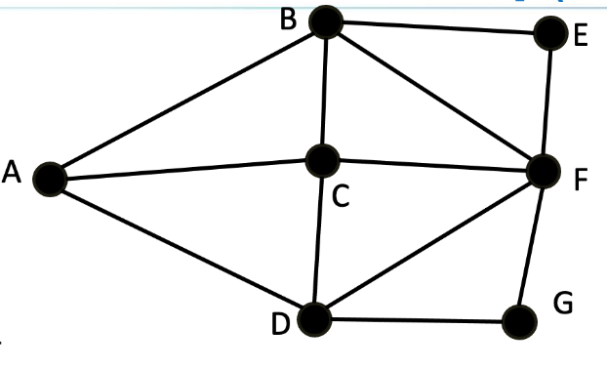

VD 5.7:

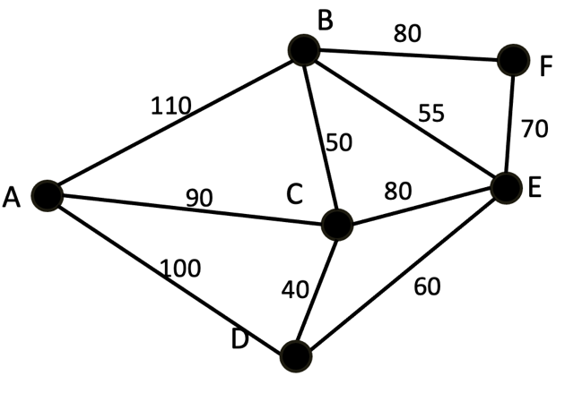

|  |  |
| --- | --- |
| Đỉnh | Danh sách kề |
| A | {B, C, D} |
| B | {A, C, E, F} |
| C | {A, B, D, E} |
| D | {A, C, E} |
| E | {B,C, D, F} |
| F | {B, E} |

VD 5.8:

|  |  |
| --- | --- |
| Đỉnh | Danh sách kề |
| A | {B, C, D} |
| B | {A, C, E, F} |
| C | {A, B, D, F} |
| D | {A, C, F, G} |
| E | {B, F} |
| F | {B, C, D, E, G} |
| G | {D, F} |

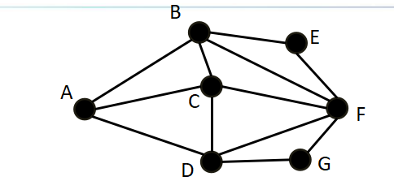

VD 5.11:

|  |  |
| --- | --- |
| Đỉnh | Danh sách kề |
| 1 | {2,3,4} |
| 2 | {1,7} |
| 3 | {1,6} |
| 4 | {1,5} |
| 5 | {4, 11, 10} |
| 6 | {3} |
| 7 | {2, 8, 9} |
| 8 | {7, 13, 14} |
| 9 | {7} |
| 10 | {5, 12} |
| 11 | {5} |
| 12 | {10} |
| 13 | {8} |
| 14 | {8} |

